

Brodie ’s

Digital Body Language Report

Your Digital Body Language

While traditional body language uses explicit cues to provide information, Digital Body Language is more implicit. Research has identified four key areas of Digital Body Language that facilitate the building of trust and connection, no matter the distance. The Digital Body Language Assessment is to measures your ability in these areas to provide you with personalised feedback and recommendations on how you can maximise your Digital Body Language skills and effectiveness.

**Communicate Carefully**

* Unambiguous
* Clear
* Synchronised
* Aligned

**Value Visibly**

* Attentive
* Appreciative
* Respectful
* Grateful

**Collaborate Confidently**

* Empowerment
* Risk taking
* Thoughtfulness
* Certainty

**Trust Totally**

* Truthful
* Prioritization
* Risk taking
* Security

**Digital Body Language**

Your Results at a Glance

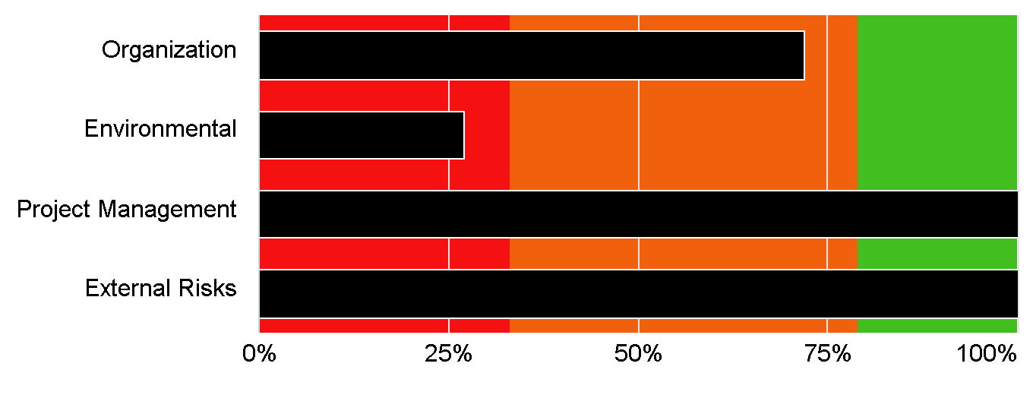

Your top Strengths and Weaknesses

Trust Totally

Value Visibly

Communicate Carefully

Collaborate Confidently

Digital Body Language

**What is Digital Body Language?**

* Since digital communication relies on how we say something rather than what we say, Digital Body Language provides an understanding of the cues used in digital communications and the messages they portray
* Digital Body Language provides an opportunity to strengthen communications by creating expectations for communicating, no matter the distance
* Traditional body language is made up of several implicit signals and cues that portray emotion and reinforce the meaning of what we are saying (e.g., eye contact, gestures, pauses, posture etc.)
* The absence of body language cues online can make it difficult to read the emotions of our colleagues, resulting in communications feeling more ambiguous, less genuine, or unengaging



**How do Traditional and Digital Body Language Compare?**

|  |  |  |
| --- | --- | --- |
| A head tilt to signal active listening |  | Reacting to a message |
| A pause before responding to carefully consider what was said |  | Taking extra time to craft an appropriate response |
| Smiling or laughing to portray emotion and enthusiasm |  | Using exclamation points in messages and emails |
| Nodding to show agreement |  | Sending a thumbs-up during a meeting |

**The Four Laws of Digital Body Language**



*Value Visibly* means being more sensitive to other people’s time and needs, reading digital communications with care and attention, and respecting other people — without being in a rush about it, either.

*Trust Totally* implies the highest levels of organizational faith, where people tell the truth, keep their word, and deliver on commitments.

*Collaborate Confidently* means taking conscious risks while

trusting that others will defend your actions and decisions. It

frees everyone up to overcome daily fears and uncertainties

and move forward from alignment to commitment.

*Communicate Carefully* means sending messages that say what we mean and what we need, from whom, and by what time frame, thereby eliminating ambiguity across teams.

**The Digital Body Language Assessment Guide**

* This guide will help you understand the different Digital Body Language Laws
* Using your responses to the Digital Body Language Assessment Guide, this guide will give a personalised insight into your own Digital Body Language style
* You will receive personalised feedback and practical recommendations on how you can master each area of Digital Body Language
* You will learn how to improve your communications, your team performance and culture, and collaboration

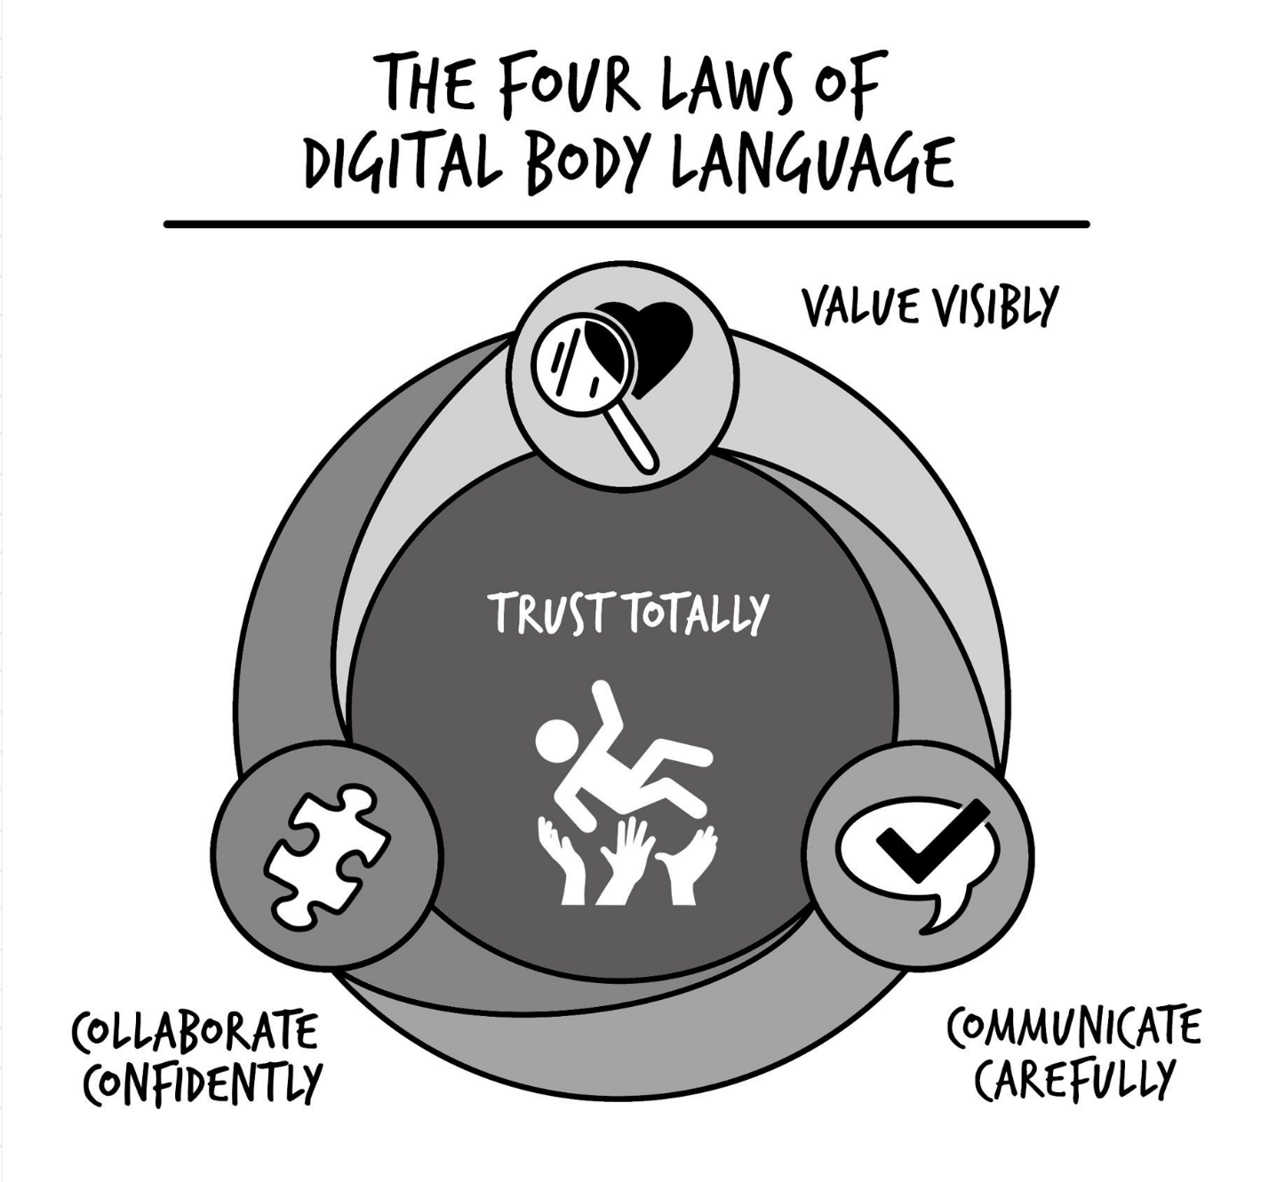Your Personalised Digital Body Language Report

Value Visibly

When we **Value Visibly**, we are attentive and aware of others and their needs. We show other people that we appreciate them and their efforts and that we respect their time. Messages are read carefully and responses are free from mistakes, meeting invites are not revoked or changed at the last minute, and we do not use the mute button as a means to multi-task during meetings. Digital channels are used in a respectful and considerate way.

You rated yourself as to Value Visibly and scored 100%

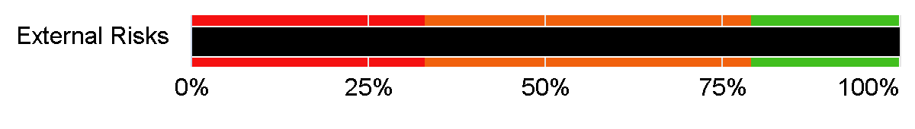

**What You can Expect from Value Visibly – The Business Benefit**

Colleagues feel seen and appreciated, increasing their engagement



Meetings are more focused and productive



Success is clearly defined, making it more achievable



Colleagues feel seen and appreciated, increasing their engagement

Communicate Carefully

When we **Communicate Carefully**, we clearly articulate across digital channels. Messages are clear and sent to the appropriate people and provide alignment on the project. We communicate what we need and when we need it by, everyone’s role is made clear to them, and the appropriate people are informed of the project and its status. Communications are carefully considered and contain all the necessary information.

You rated yourself as to Communicate Carefully and scored 100%

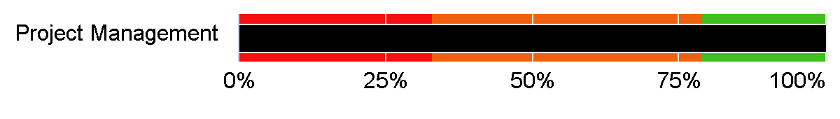

**What You can Expect from Communicate Carefully – The Business Benefits**

Deadlines are clearly communicated, streamlining the project



Everyone knows their role and what is expected of them



Communications are more effective, and a response is received when expected



Collaborate Confidently

When we **Collaborate Confidently**, we foster open, thoughtful communication. We know we will receive adequate support, we assume our colleagues have good intentions, and are not met with unrealistic expectations. Team members are empowered and free to take calculated risks, ambiguity is not met with fear, and we do not feel pressured to reply to messages immediately. Collaborations are thoughtful and considerate.

You rated yourself as to Collaborate Confidently and scored 27%

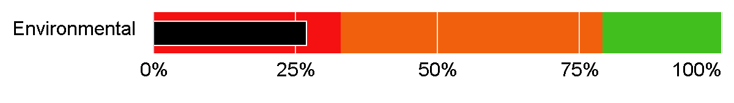

**What You can Expect from Communicate Carefully – The Business Benefits**

Deadlines are achievable and agreed by relevant parties



Meetings are more interactive and beneficial for all

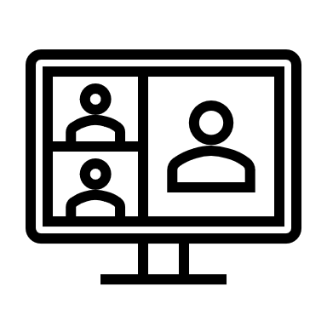

Relevant departments and stakeholders are aware of projects and their status, preventing work being duplicated

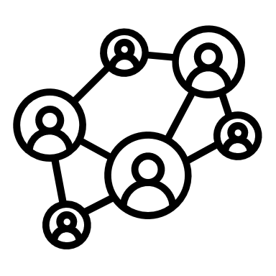

Trust Totally

When we master the other three laws, we **Trust Totally**. We are truthful, considered and experience psychological safety. Interactions are genuine and inclusive and issues are dealt with appropriately. Teammates are consulted and interactions are anxiety-free.

You rated yourself as to Trust Totally and scored 0%

**What You can Expect from Trust Totally – The Business Benefits**

Deadlines are clearly communicated, streamlining the project



Communications are more effective, and a response is received when expected



Everyone knows their role and what is expected of them



Our Products and Services

Work with Erica Today

|  |  |
| --- | --- |
|  | Keynote Presentations   * Master the fundamental laws of Digital Body Language * Learn tactical strategies and tools to lead, no matter the distance * Gain insights to build virtual trust and collaboration |
|  | Custom Workshops   * Assess your Digital Body Language style and opportunities * Identify key collaboration pain points and improvements * Improve leader and team alignment, motivation, and performance |
|  | Train The Trainer Programs   * Implement new collaboration practices across teams and the entire organization * Transform your organization to a digital ready culture |
|  | Online Courses   * Get noticed, improve collaboration across silos, and drive industry-changing innovation * Build trust & connection no matter the distance |
|  | Digital Body Language Assessments   * Learn individual, team, and organizational gaps on collaboration and communication * Gain data-driven insights on employee engagement, satisfaction, and innovation |

